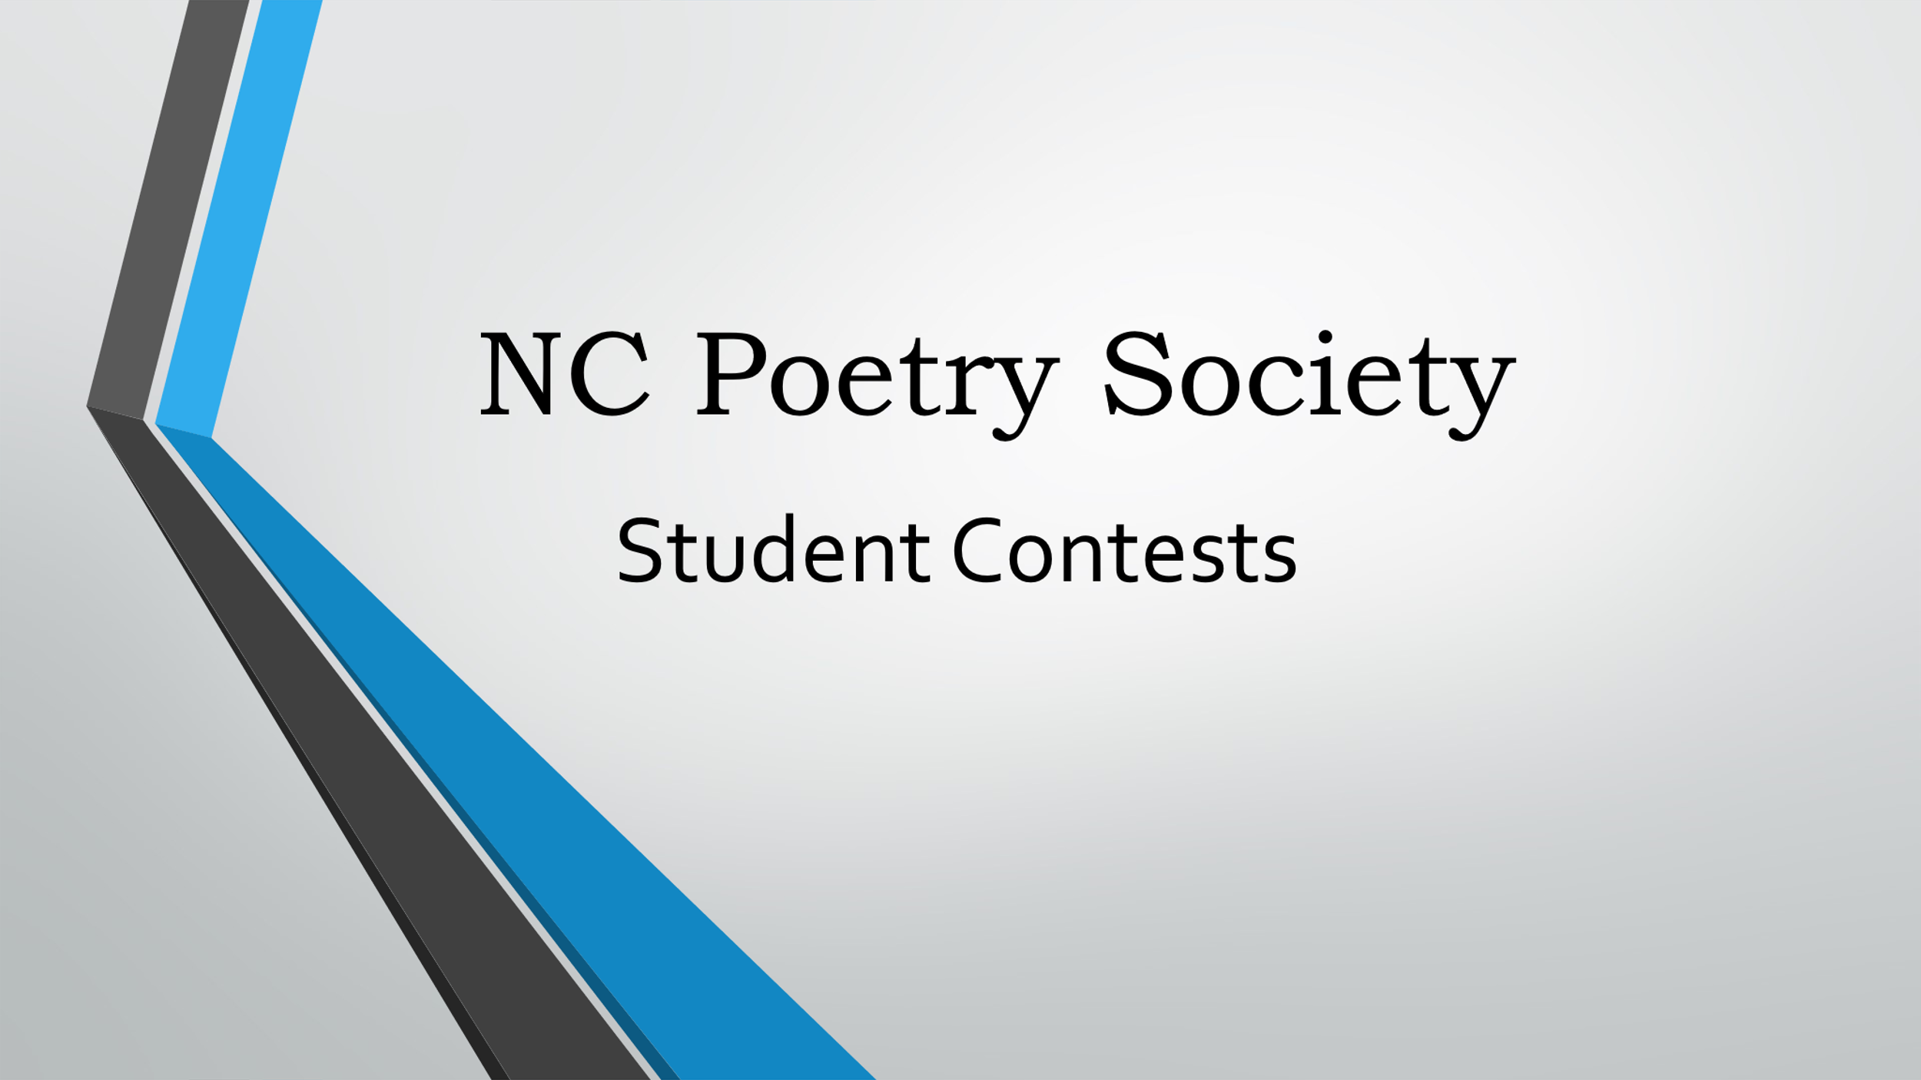

**Submission Form for North Carolina Students**

Please print this form and sign in ink. **Do not type the signatures.**

Name of the award category: ______________________________________________________

Poem title: ____________________________________________________________________

Student’s name: (first) ________________________(last)_______________________________

Student’s email (optional except for Undergraduates): _______ _______________________________

Student’s home address: _________________________________________________________

City: _____________________________________________ Zip code: ____________________

Student’s grade or college academic year: ____________________________________________

Name of student’s school / Home school (circle 1): ______________________________________

Teacher’s / Parent’s / Mentor’s (circle 1) name: ________________________________________

Teacher’s / Parent’s / Mentor’s (circle 1) email: _________________________________________

For the student:

By signing below, I pledge this is an original poem that I wrote. It was not created by artificial intelligence. SIGN. DO NOT TYPE.

Student’s signature: _____________________________________________________________

Teacher’s / Parent’s / Mentor’s (circle 1) signature: _____________________________________

(Teacher’s/Parent’s/Mentor’s signature not needed for undergraduate submissions.)

Date: _________________________________________________________________________

**Email** the completed form as a scanned PDF attachment—or take a picture of the completed form with your phone—and send it to the contest coordinator or

**mail** this completed form and two copies of your poem to Nancy Martin-Young, NCPS Student Contests Coordinator, 187 Yates Lane, Lake Lure, NC 28746.